GEN AI HANDS ON 1
NAME: ARCHIT RODE
SECTION: B
SRN: PES2UG23CS088

Seed Value:

With seed value 42
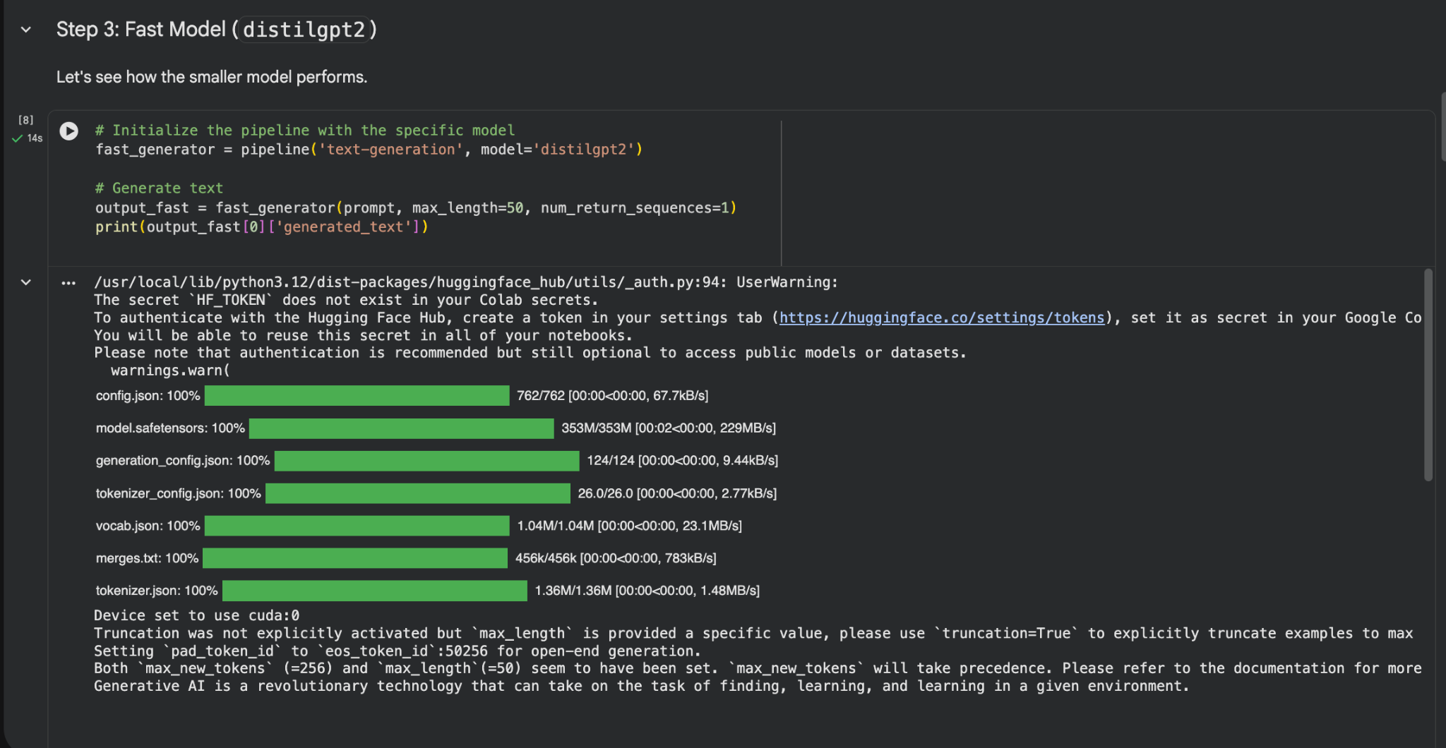
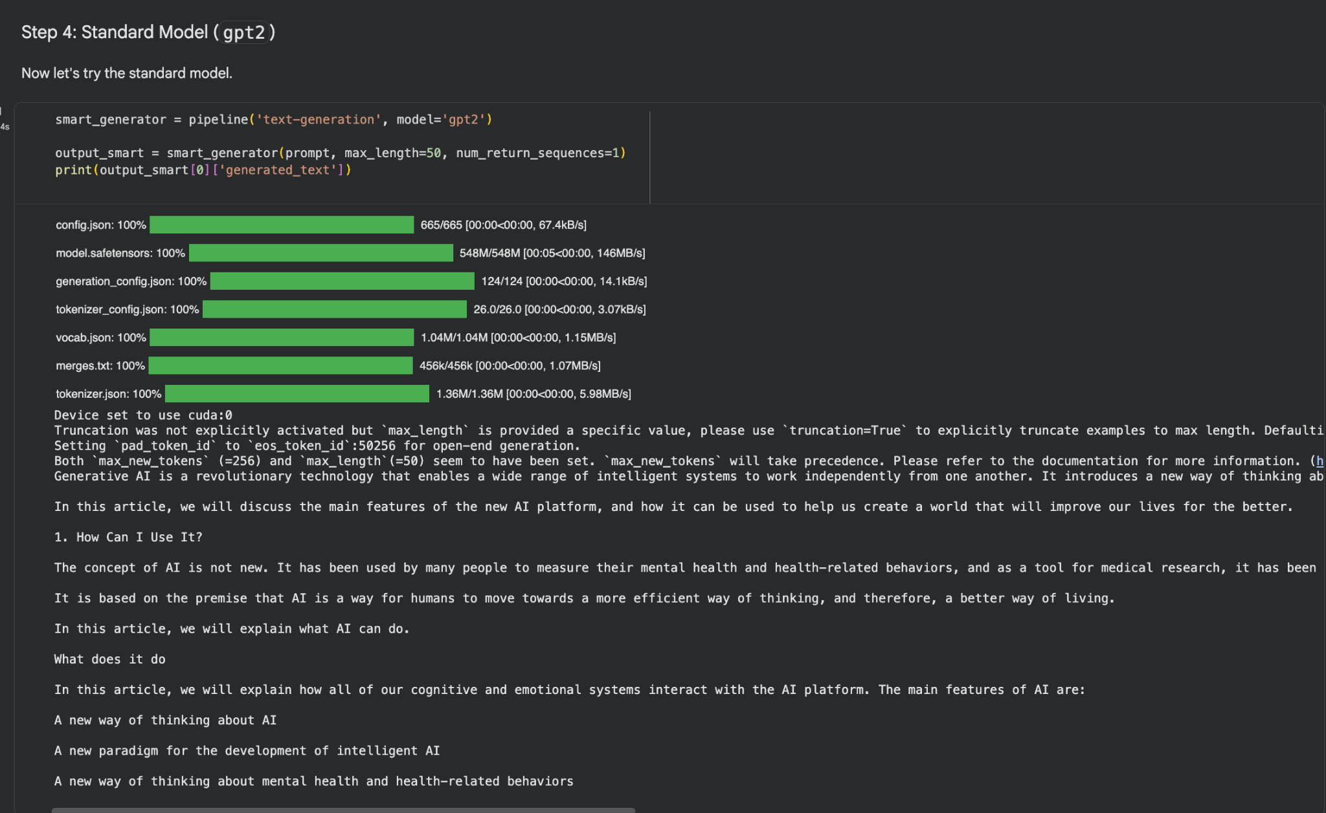
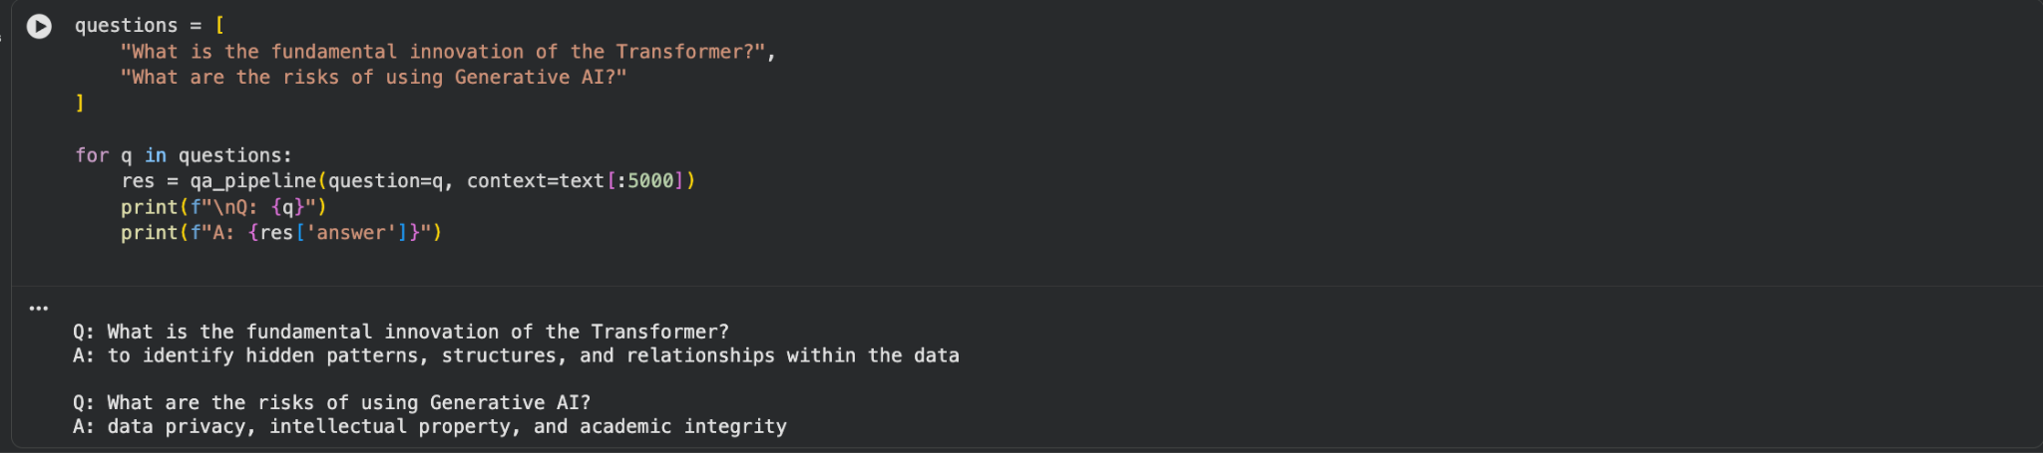

Now for Seed Value 65, the changes in the output will be slightly different but the context of the model remains the same.
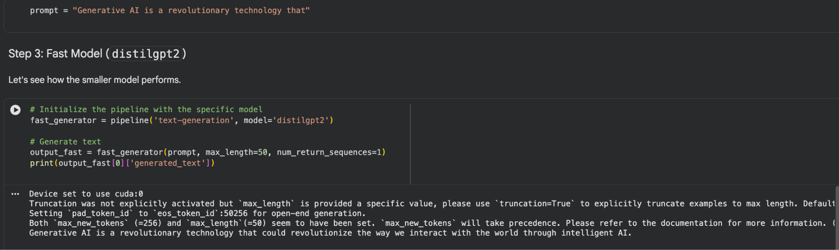
We can see that the output here is slightly different compared to the one with the output of 42 which was “that can …” here it is “that could …”
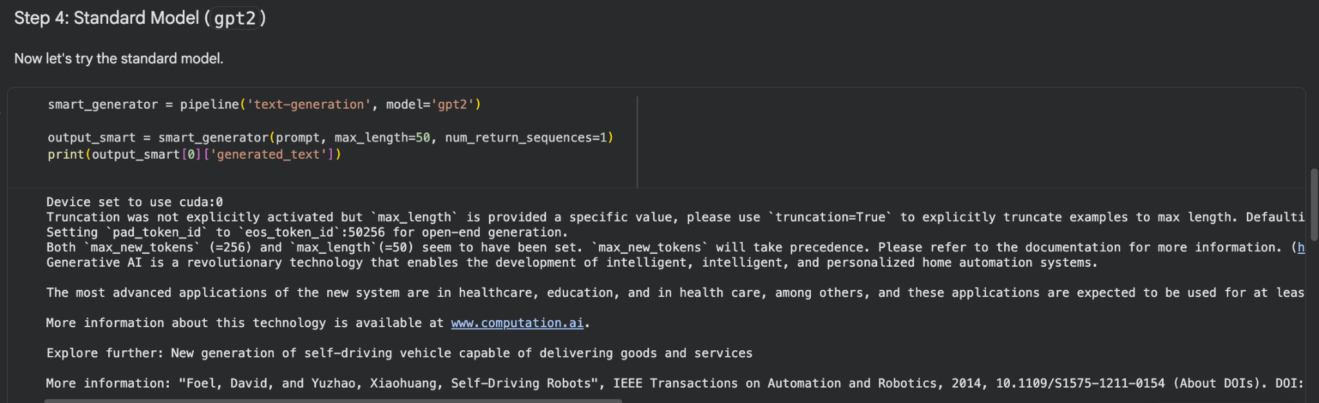

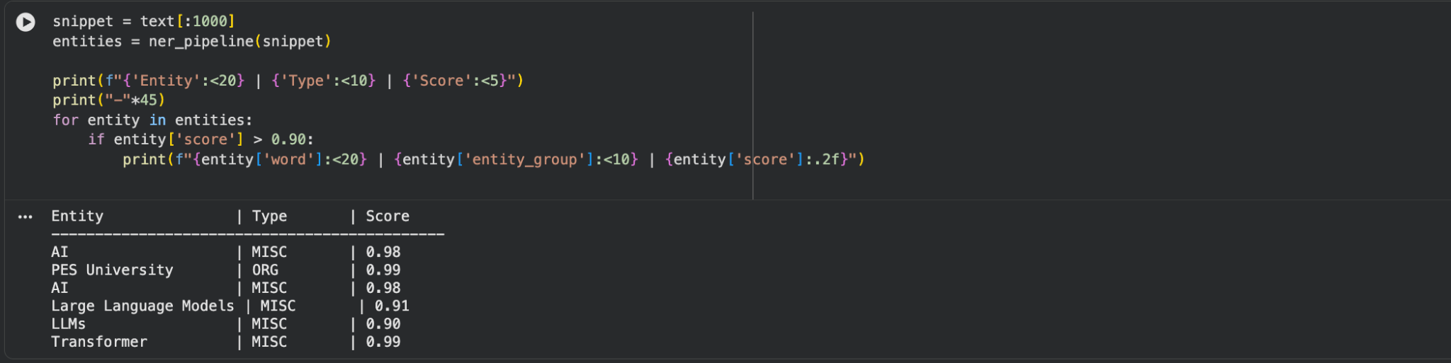
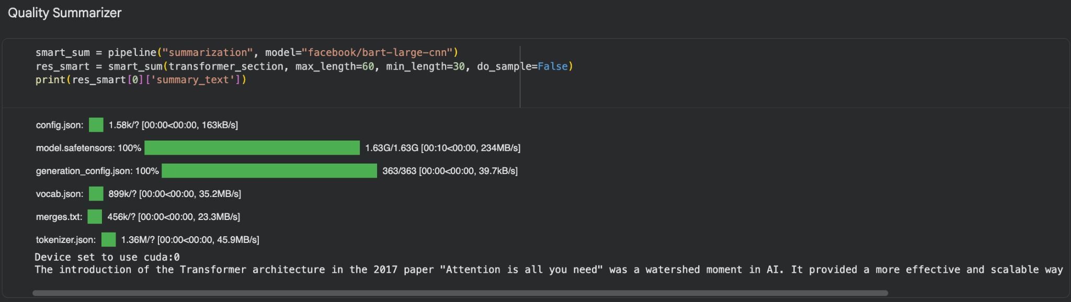
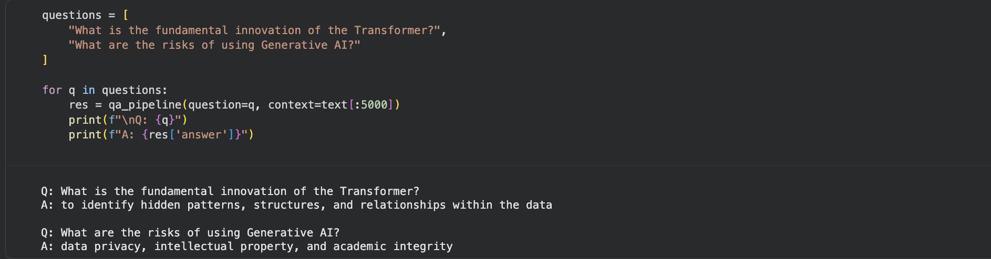
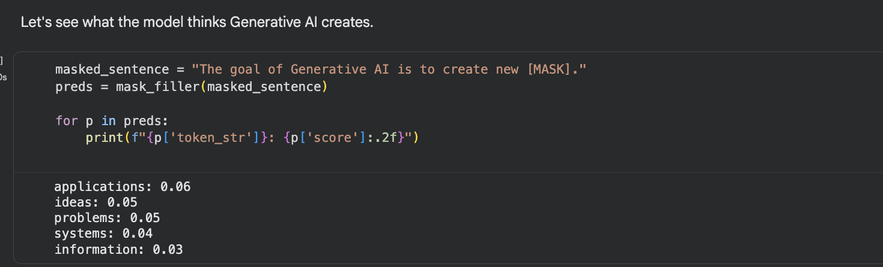

For the parts of speech we have these few common tags:

NN: Noun
VBZ: Verb, 3rd person singular present tense
JJ: Adjective
DT: Determiner
IN: Preposition or subordinating conjunction
RB: Adverb
PRP: Personal Pronoun

- BERT is designed for deep language understanding, while GPT-2 is designed for fluent text generation
- Hugging Face is a popular machine learning platform focused on natural language processing. It provides pre-trained models, datasets, and tools (like Transformers) that make it easy to build, train, and deploy ML models for tasks such as text generation, translation, and sentiment analysis.
- BART supports text generation using an encoder–decoder architecture, while BERT is encoder-only and designed for language understanding.

